The activities in pink will be added to the stream to allow you access to them.
Numeracy Learning 8th June
Learning Outcomes | This week we will be working on simple fractions.  I am developing my understanding of simple fractions.  - Understand fractions of shapes need to be in equal parts.  - Understand that a shape cut into two equal parts is called a half.  - Know that two halves make one whole.  - Understand that one half can be written as ½ .
Halves Videos | 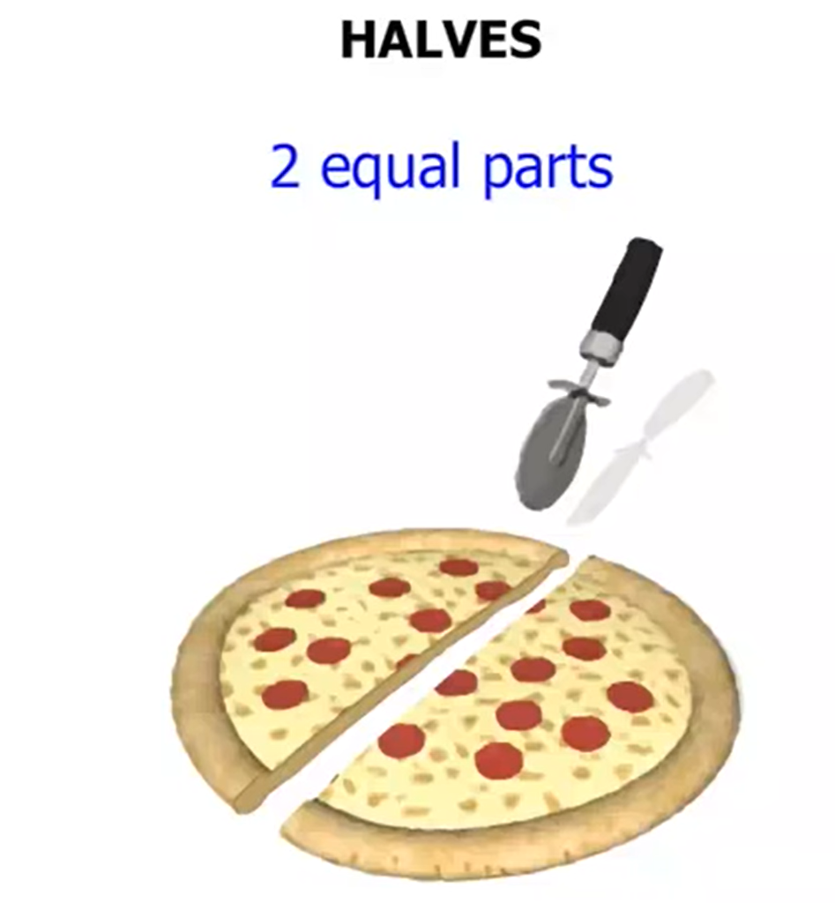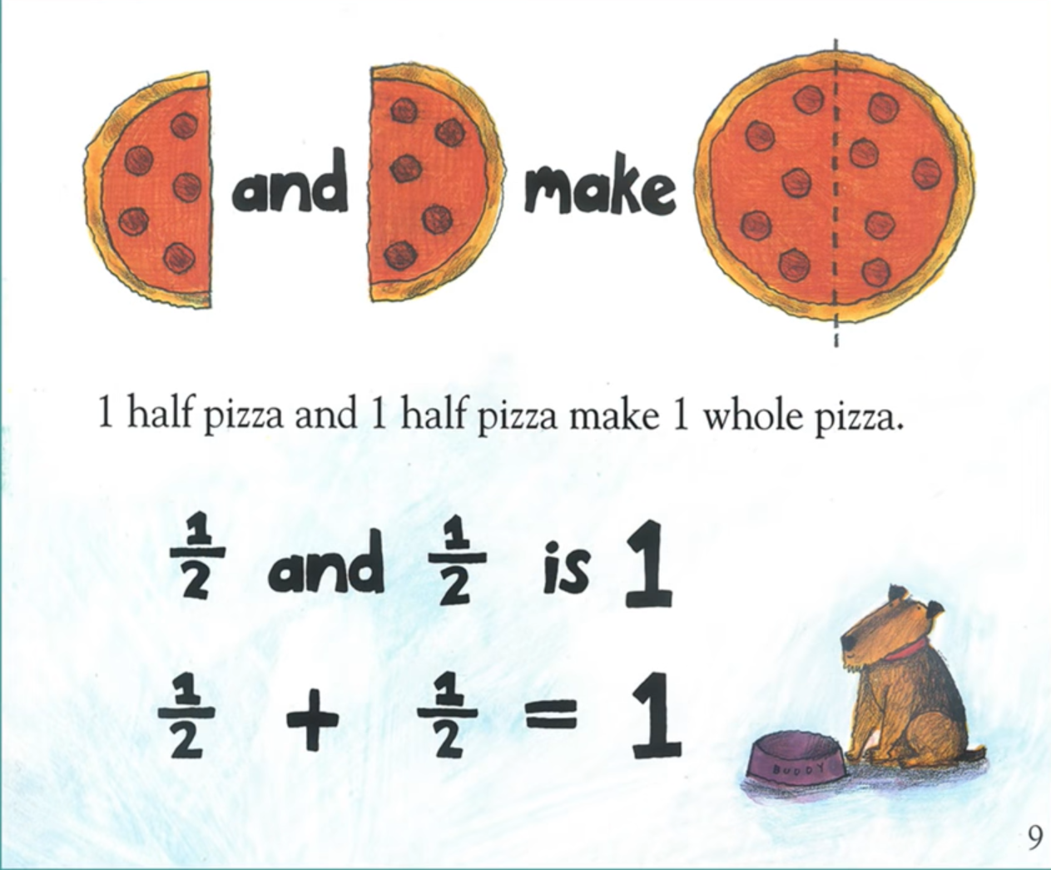  What is a half? Story about halves.
Halves Activities | 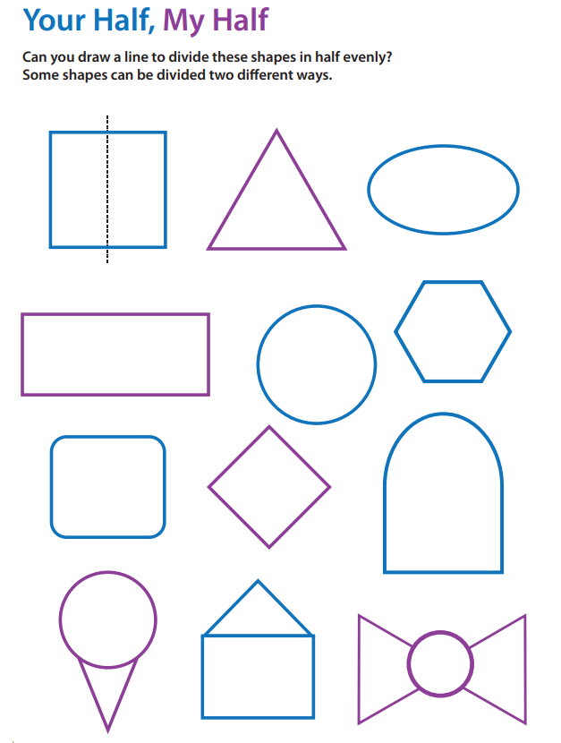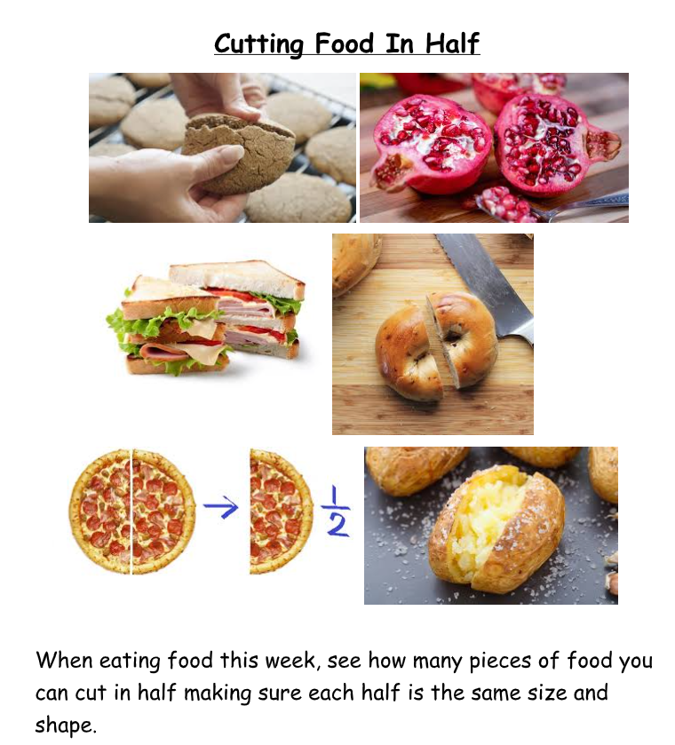  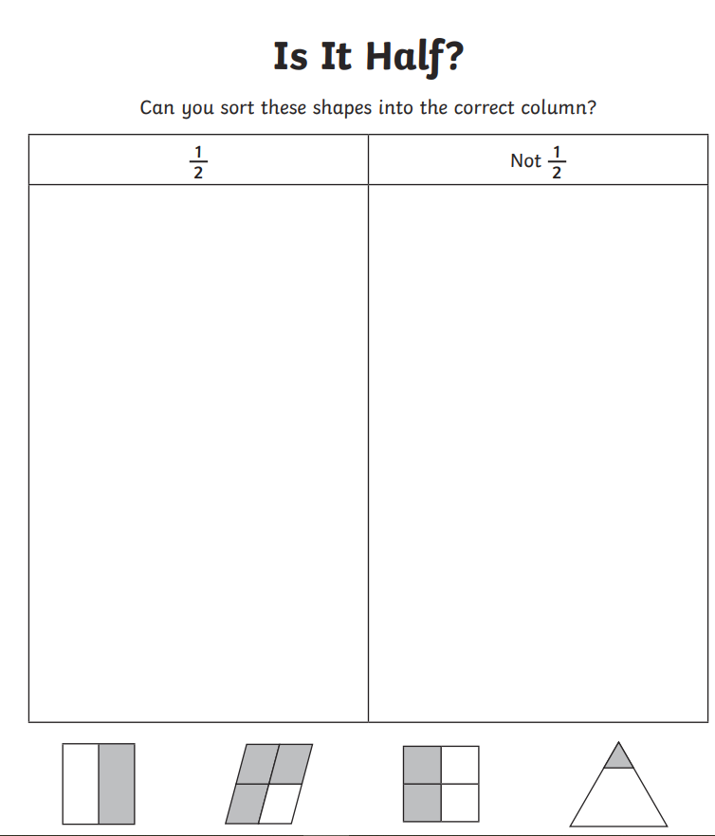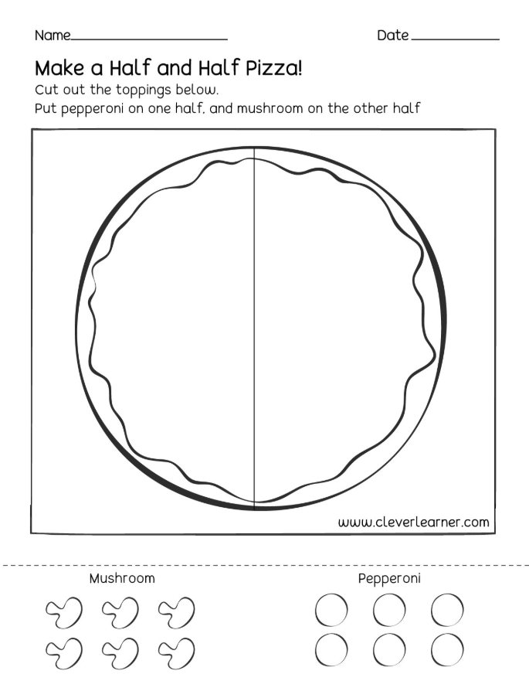
Halves Games | 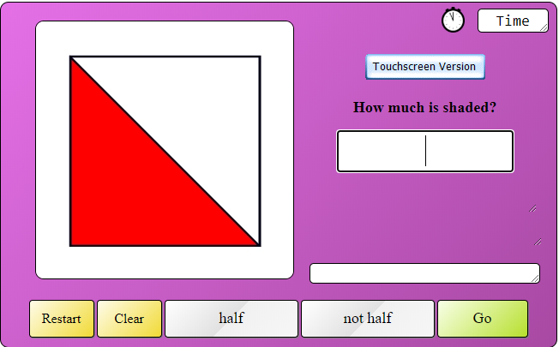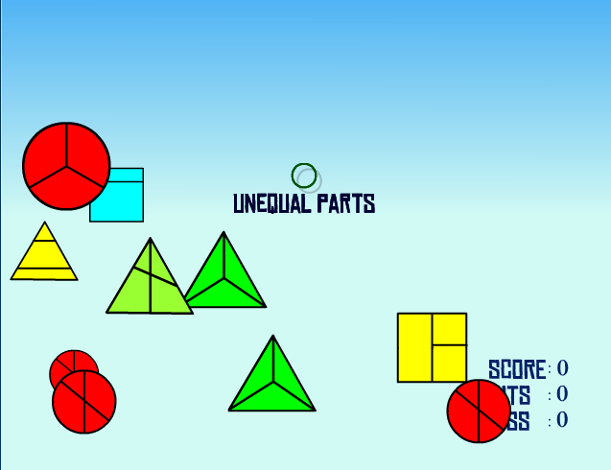
NumberJacks Halves | 