The activities in pink will be added to the stream to allow you access to them.
Numeracy Learning 22nd June
Learning Outcomes | This week we will be working on measuring.  I am developing my understanding of measuring using standard and non-standard units.  - Start and finish measuring at the correct place.  - Understand what hand spans/feet measurements are.  - Measure correctly in hand spans/feet without overlapping or spaces.  - Estimate how long objects might be before measuring.  - Understand how balance scales work.  - Use balance scales to compare the weight of two objects.  - Use non-standard units to measure the weight of objects.
Length | Watch these measuring instruction videos.  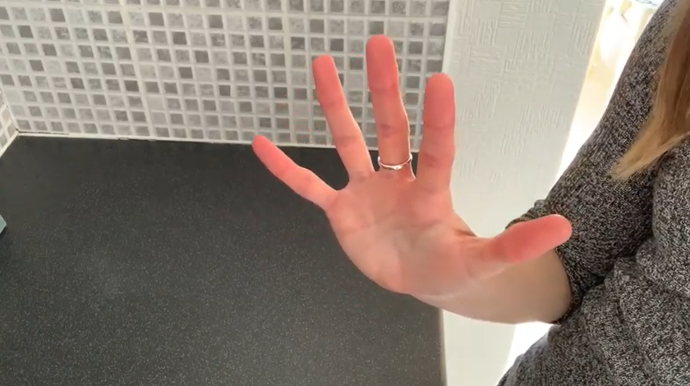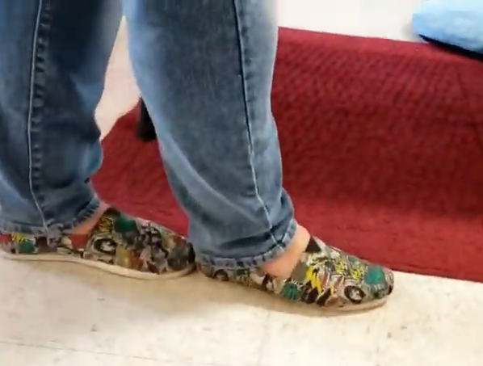  Measuring using hand spans Measuring using feet  - Find out who has the biggest/smallest hand span in your house?  - Find out who has the largest/smallest feet in your house?  Find five objects in your house and complete the table.  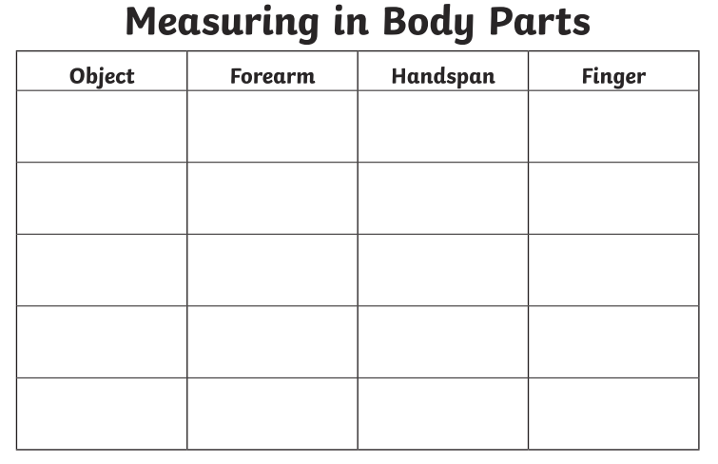  It is also important to estimate or make a guess as to what your answer might be before measuring. Now find five more objects in your house that you can measure  with your feet. Guess how long your object is in feet then check by measuring with your feet. Complete the table to show your results.  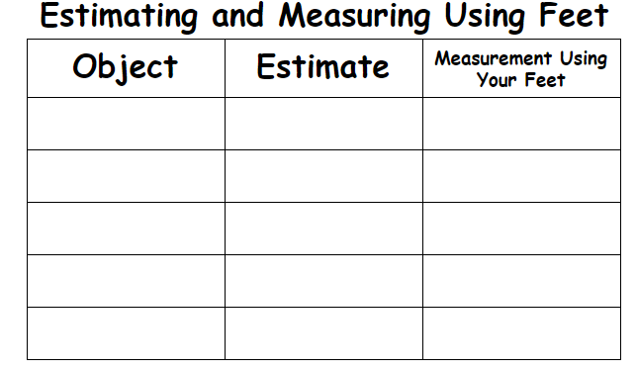
Weight | As you do not have access to balance weights we will have to improvise and make them. The easiest one I have found is the one below. Make sure you use string the same length and the same pots to make the measuring more accurate.  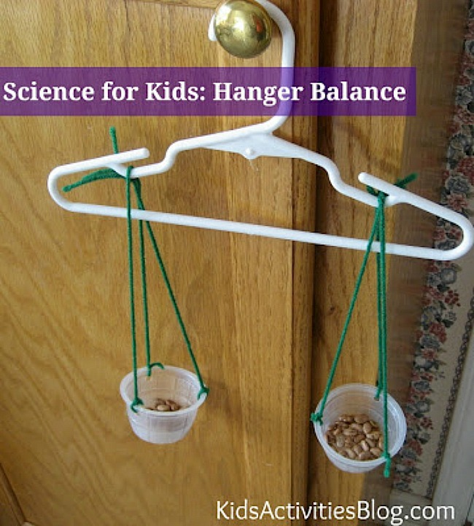  Watch the video below to show how balance scales work.  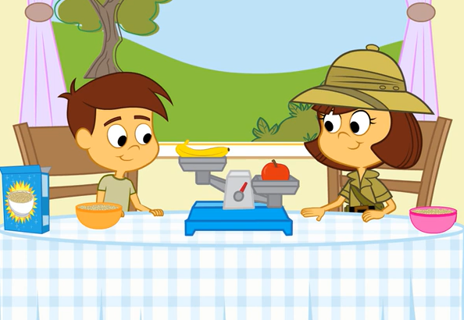  Comparing Objects  Find some objects around the house and compare them. Guess which one is lighter/heavier. Use your scales to find out and record on the sheet.  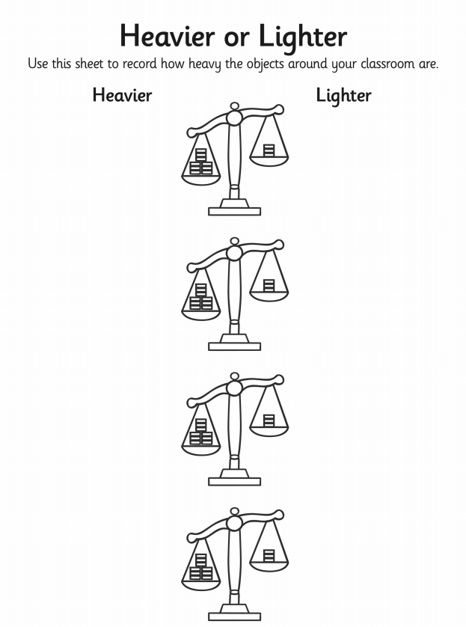  Weighing using non-standard units  Use 1p coins. paper clips or clothes pegs to measure different objects and complete the table.  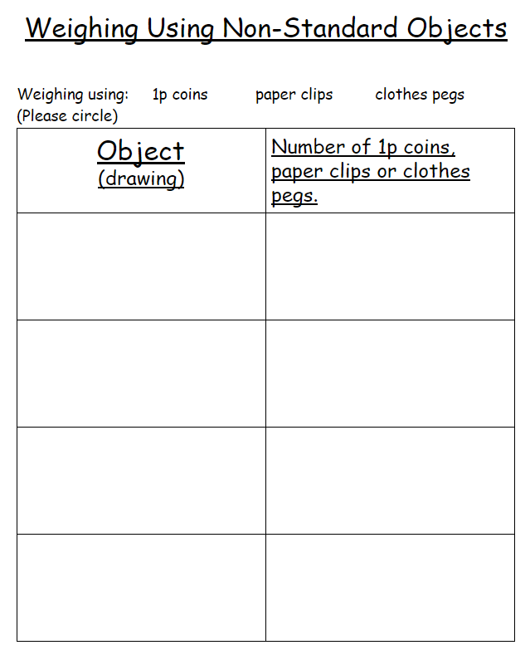  Challenge  Can you find two different objects in your house that weigh exactly the same? Use your balance scales to find out. How do you know that they weigh the same?
Games | 