The activities in pink will be added to the stream to allow you access to them.
Literacy Learning 22.06.20
Phonics | - This week we will be learning to make and break words with blends at the beginning of words e.g. br, cr, pr, fr, bl, cl, fl, sl, sn, sm (consonant blends).  - Watch the clips to learn about blends.  - 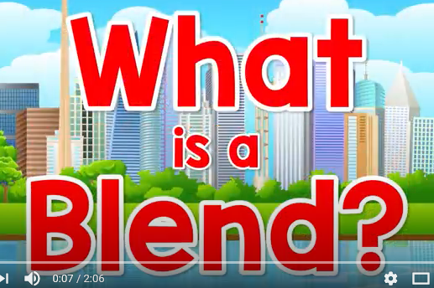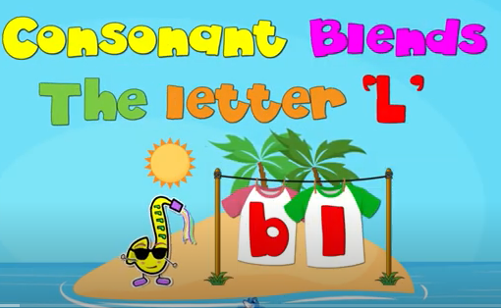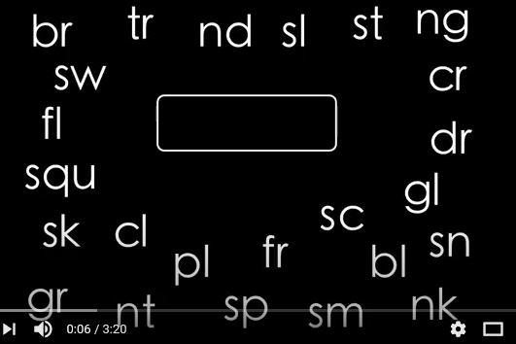  - Have a look at the blend chart. Practise saying the blends out loud.  - Have a game of I spy or a Sound Hunt. Can you find things beginning with some of the consonant blends?  - Write a word list using the blends’. How many words did you think of?  - Watch Alphablocks  - Choose from the following activities to practise the consonant blends - cut and stick, missing sounds, 4 in a row, match pictures and words  - Here are some sound games for you to have a go at.  Galactic Phonics Bowling Alley  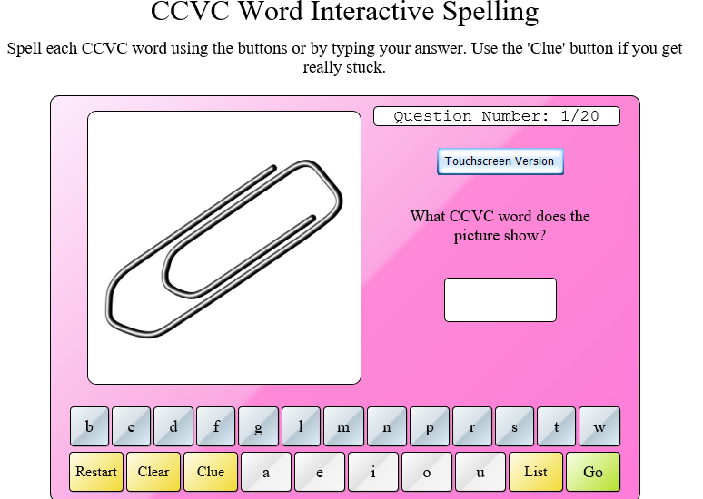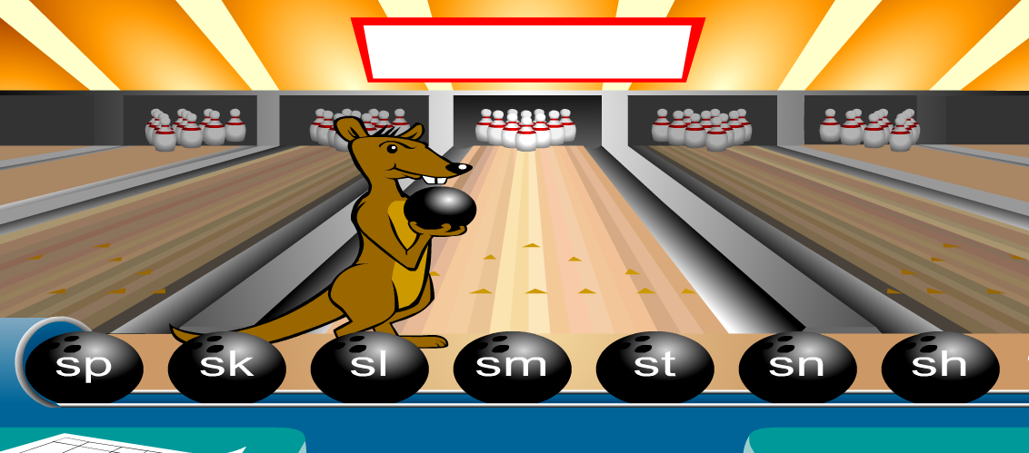  Word Warehouse Forest Phonics - blends  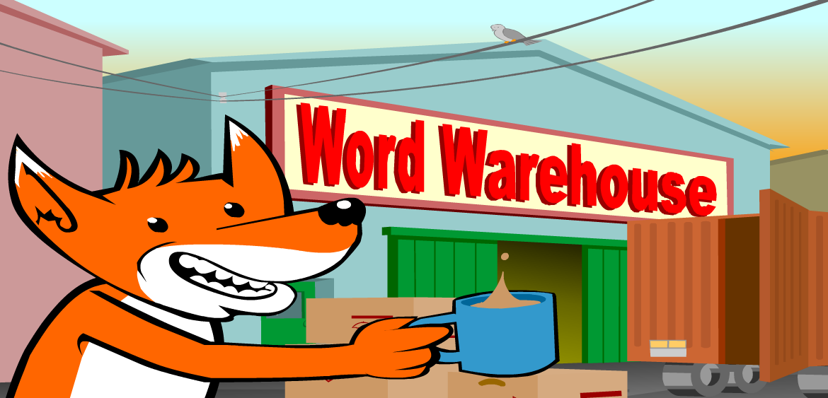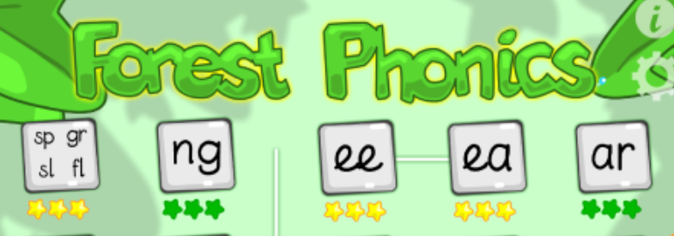
Handwriting | 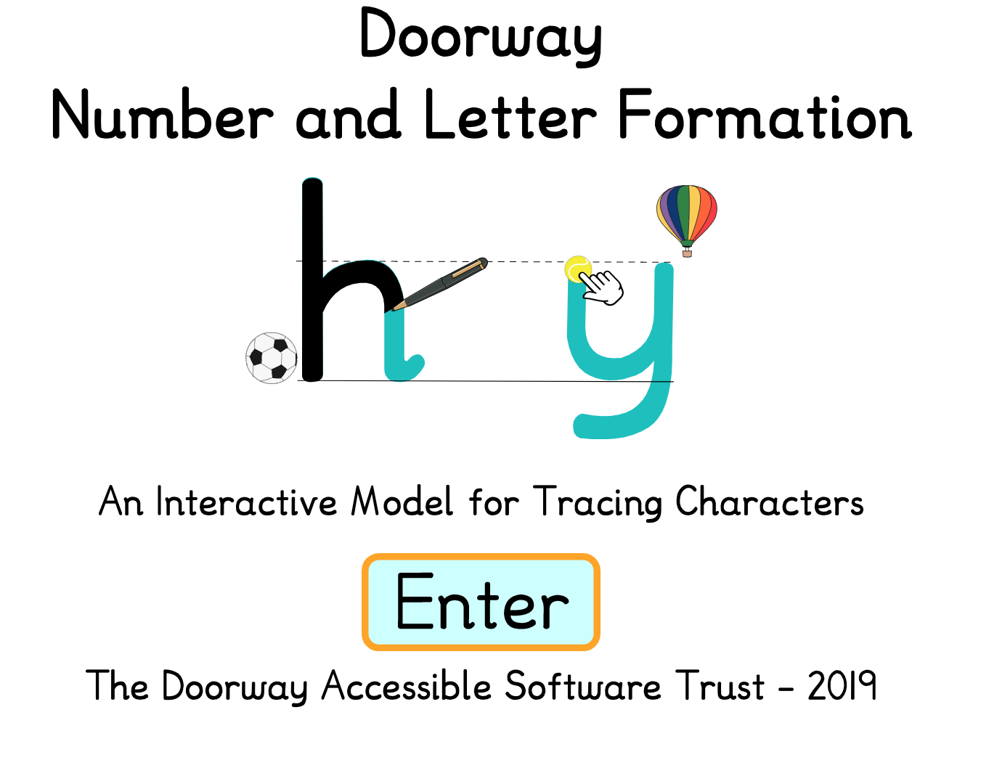  - We know you are all great at writing your first name but this week practise writing your first name and your surname. Don’t forget you need to have capital letters at the beginning of each name e.g.  Christopher Robin
Reading | - Practise the High Frequency Words in your yellow books. Remember these are sight words. You can use phonics clues to help you but we are really looking for these words to be ‘look and say’ words.  - Use the Read and Write strips - practise reading/writing phonics sentences. Ask someone at home to read a sentence out loud to you. You repeat the sentence, counting the words and then write it down correctly. How did you get on? Try again!
Listening, Talking and Writing | - This week please see Health and Wellbeing Planner for 22.6.20 - Transition Activities  - Listen to the story ‘When I grow up’
Spelling | 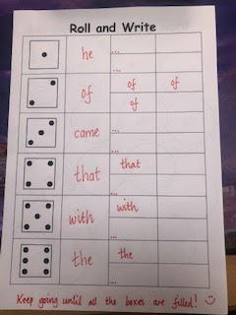  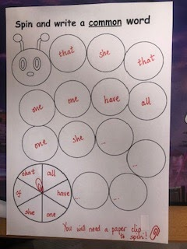  - Practise either the Bronze, Silver and Gold spelling words according to the level you were working on. Play some of the games or activities suggested below.  - Spin a Common Word or Roll and Write  - Little Bird Spelling  