The activities in pink will be added to the stream to allow you access to them.
Numeracy Learning 15th June
Learning Outcomes | This week we will be working on simple fractions.  I am developing my understanding of simple fractions.  - Understand fractions of shapes need to be in equal parts.  - Understand that a shape cut into two equal parts is called halves  - Understand that a shape cut into four equal parts is called quarters  - Know that two halves/ four quarters make one whole.  - Understand that one half can be written as ½ and one quarter ¼  - Quick recall of halves to 10. e.g. half of 6 is 3, 8-4
Halves/ Quarters Videos | 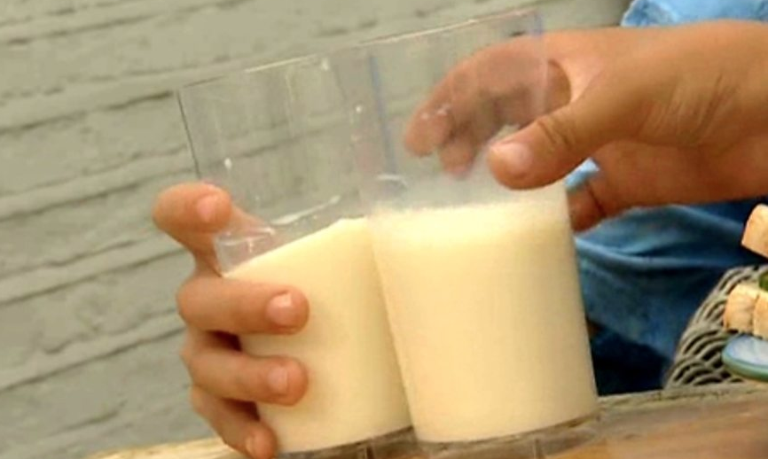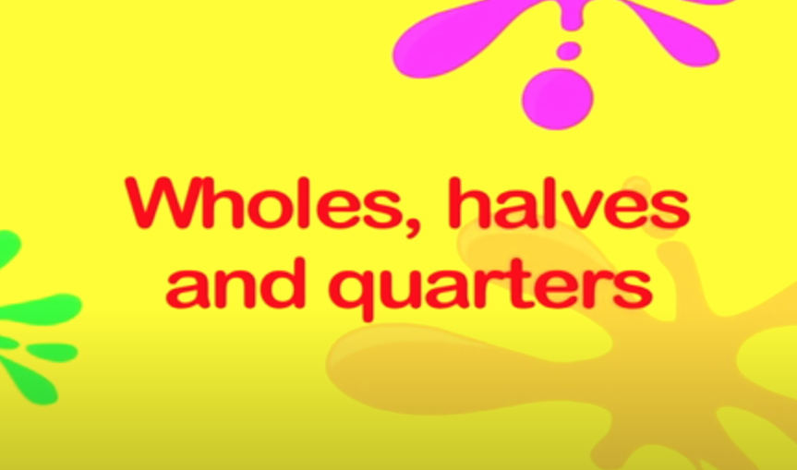  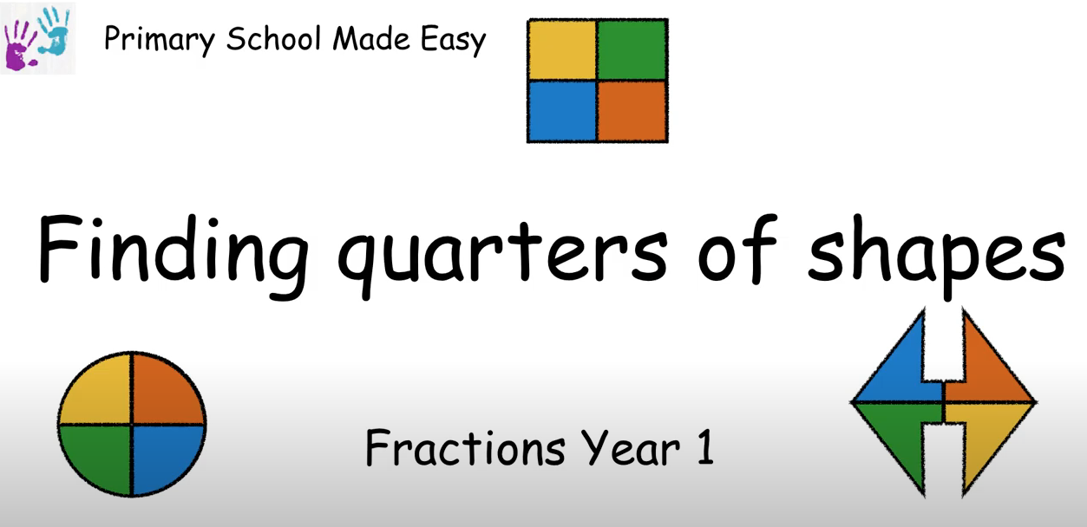
Halves Activities | 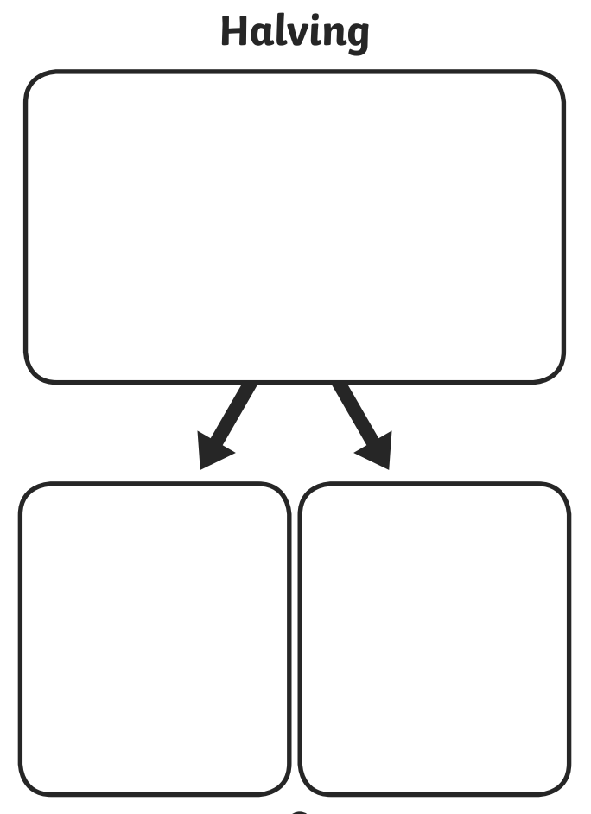  Half of an amount  Use the halving mat to practise finding half of an amount! Use counters, lego, cereal, pasta, buttons etc from home.  Into the big box at the top count out an amount e.g. 8. Split 8 into two equal groups. How many in each group?  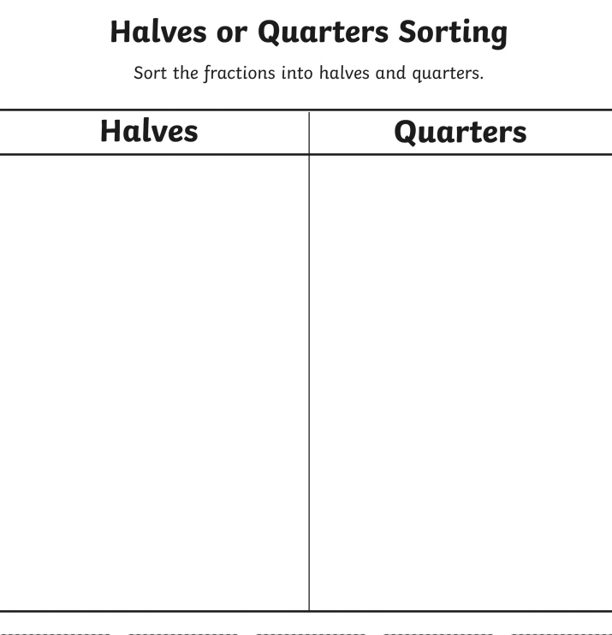  Now try with other amounts in the top box e.g. 4, 6, 10, 2, 12, 14, 20.  How did you get on?  Quarters - Sorting  Cut and Stick the fractions to sort into halves and quarters.  Try any of the activities below:  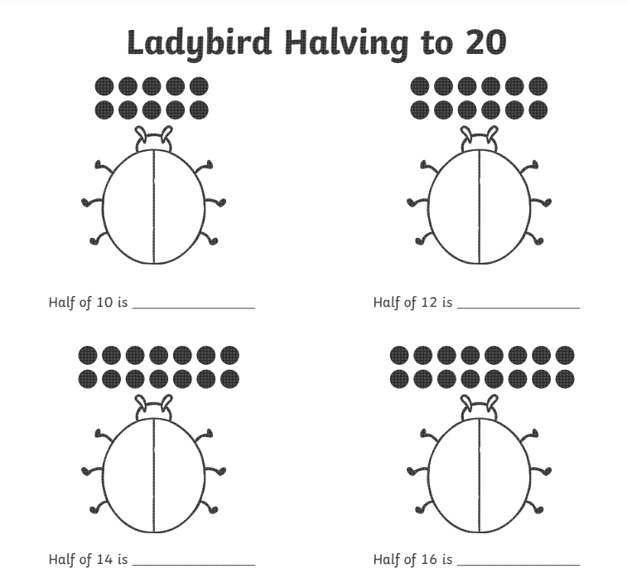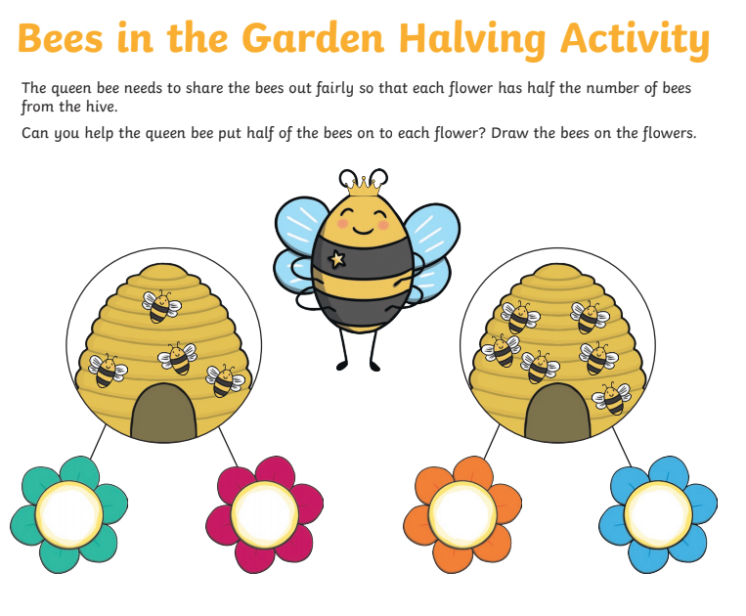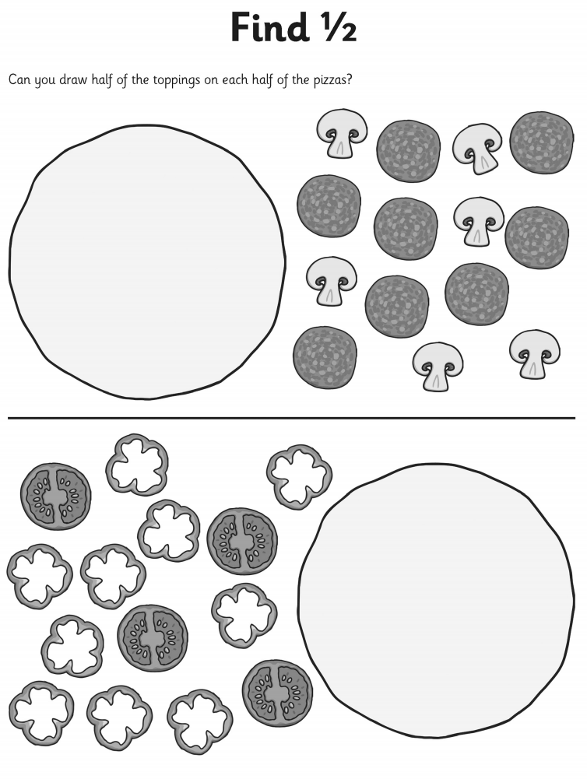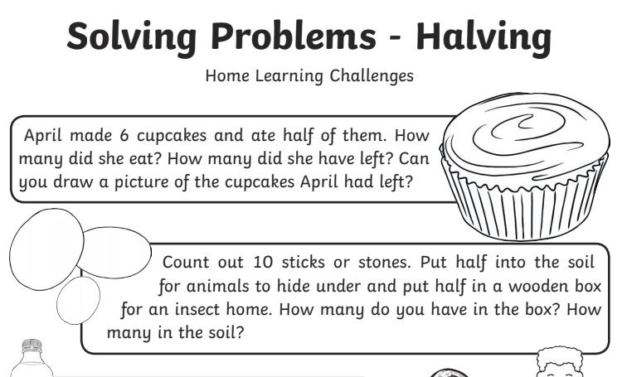
Online Games | 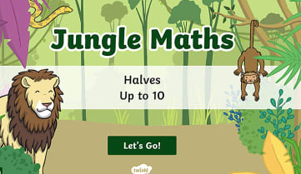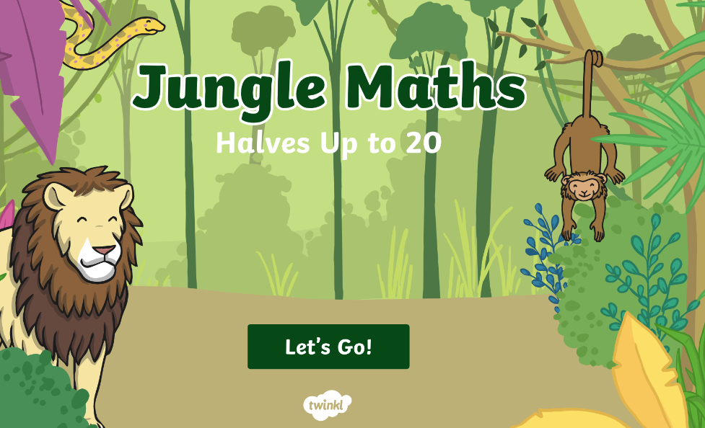  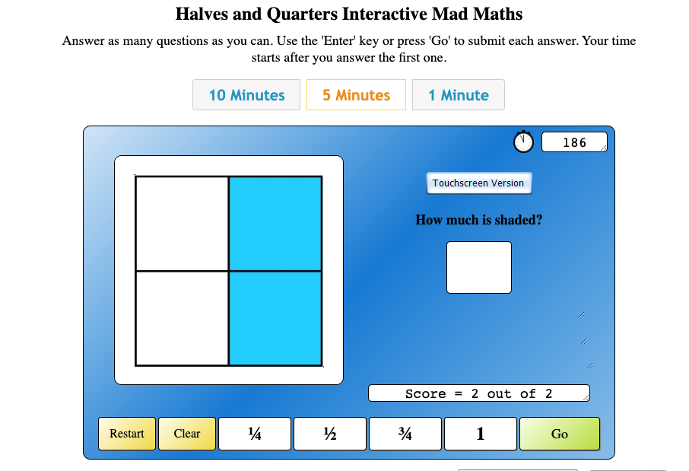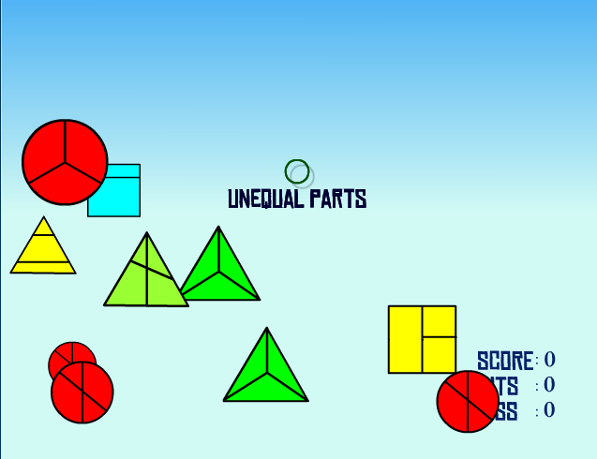
PowerPoint Activities | 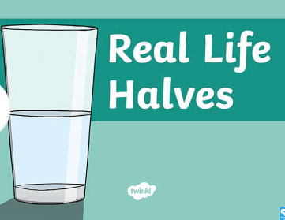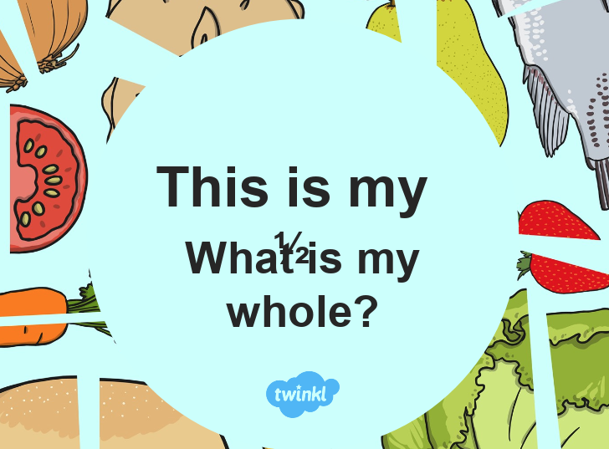  See attached files

