The activities in pink will be added to the stream to allow you access to them.
Literacy Learning 15.06.20
Phonics | - This week we will be learning to make and break words with the sound ‘zz’’. Remember there are two letters but only one sound!  - Watch the clips to learn some words with “zz”’. 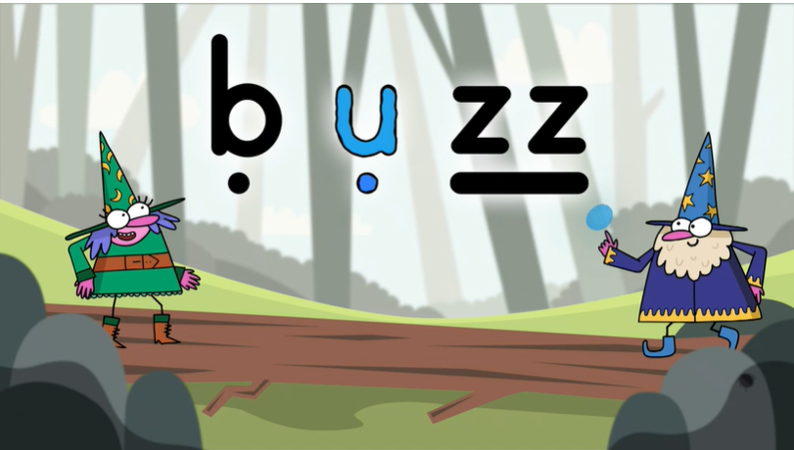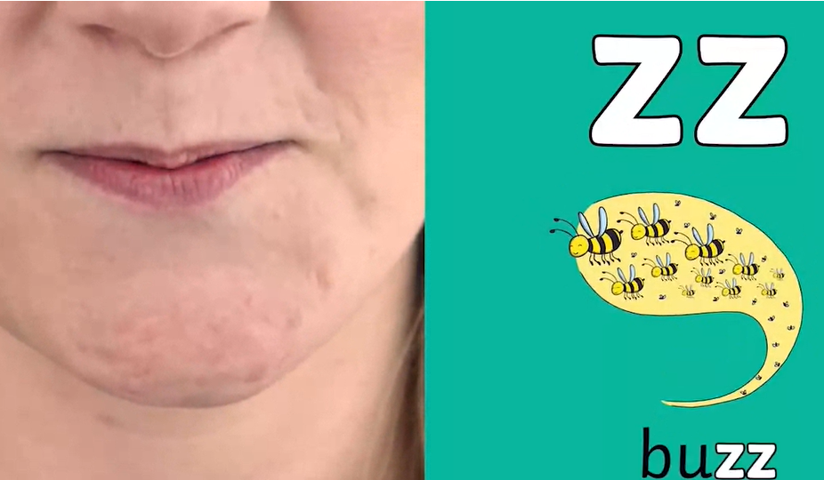  - Play 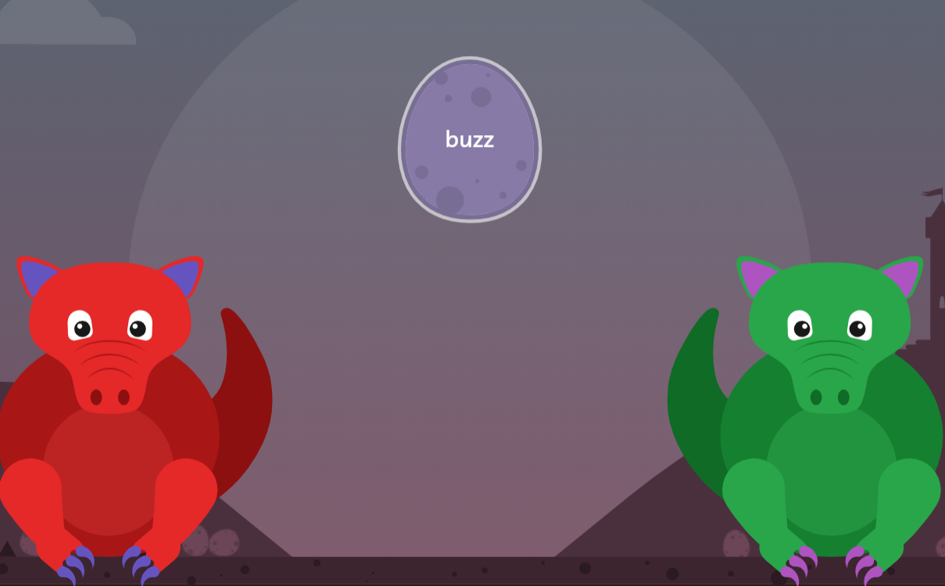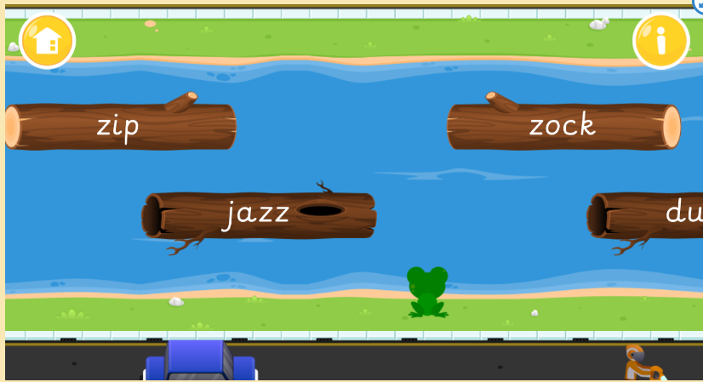  - Watch Alphablocks zz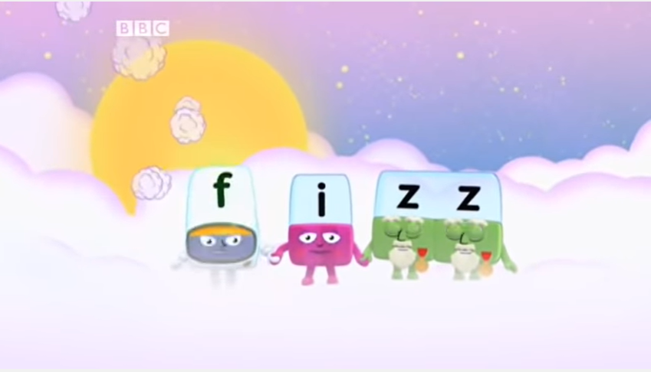  - Write a word list using the sound ‘zz’. How many words did you think of?  - Choose from the following to practise the “zz” sound - snakes and ladders, battleships, spin it, read and roll, noughts and crosses.  - Read and Write strips - use these to practise reading phonics sentences. Ask someone at home to read a sentence out loud to you. You repeat the sentence, counting the words and then write it down correctly. How did you get on? Try again!  - We are looking at checking your work to make sure it makes sense. Play this game to practise reading over work to make sure it makes sense.
Handwriting | 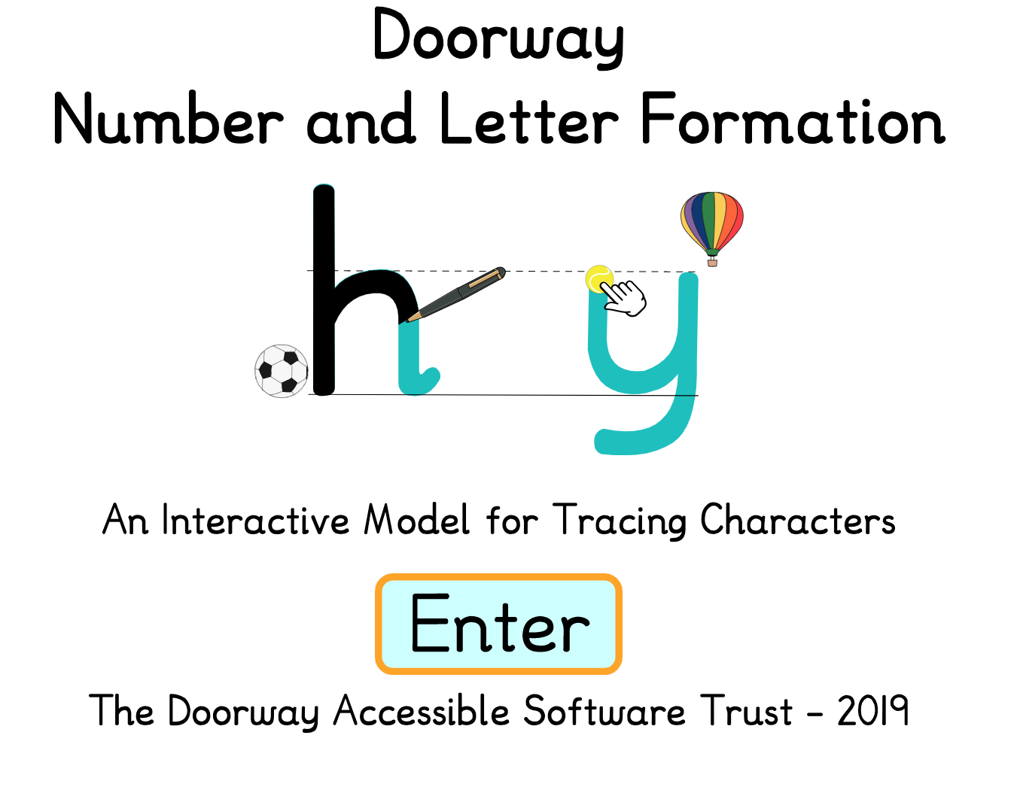  - Keep practising the correct letter formation Use the Number and Letter Formation activity to help with your handwriting. You can choose the letters or numbers you need to practise, follow on the screen and then practise writing.  - If you can write all your letters correctly, have a go at writing the capital letters. Take care to write the capital letters the correct size. Try the Capital Letter Game!
Reading | - Practise the High Frequency Words in your yellow books. Remember these are sight words. You can use phonics clues to help you but we are really looking for these words to be ‘look and say’ words.  - Find the punctuation in the stories that you read: full stop, question mark and exclamation mark. Play along with the punctuation game.  - Have fun reading with ‘ I Like Soccer”  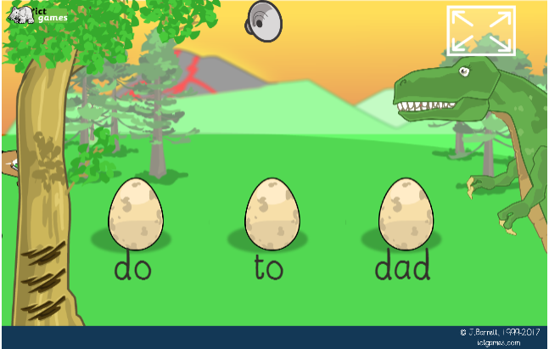  - Have fun with “Frank The Fish Gets His Wish” (Slinky Malkiki Team)  - Complete the Follow Up Activities for the book.  - Play “Dinosaur Eggs” to read high frequency words. Stage at stage one and if you find that easy move onto the next level.
Listening, Talking and Writing | - Listen to the story “Wee Granny’s Magic Bag”  - This week we would like you to imagine that you had a magic bag. Draw a picture of what it would look like.  - Now write some sentences about your picture. What would you like to pull out of your bag. Tell us why you would pick those items. Write one sentence at a time. Check that you have a capital letter, full stop and finger spaces before writing your next sentence.  - Have a go at spelling the words yourself. Try to sound them out but don’t panic if they are not correct
  C |  | 
Spelling | 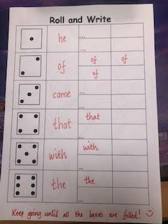  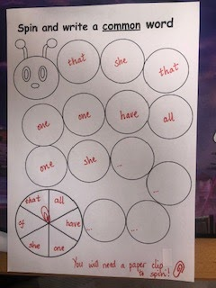  - Practise either the Bronze, Silver and Gold spelling words according to the level you were working on. Play some of the games or activities suggested below.  - Spin a Common Word or Roll and Write  - Spooky Spelling - tricky words

